**Linux Commands**

1. Create the following directories: HR, Operations, Finance

Test1, Test2, Test3, Operation1, Operation2, Finance1, Finance2 (create files)

**Command:**

**mkdir -p HR Operations Finance**

**touch HR/Test{1..3} Operations/Operation{1..2} Finance/Finance{1..2}**

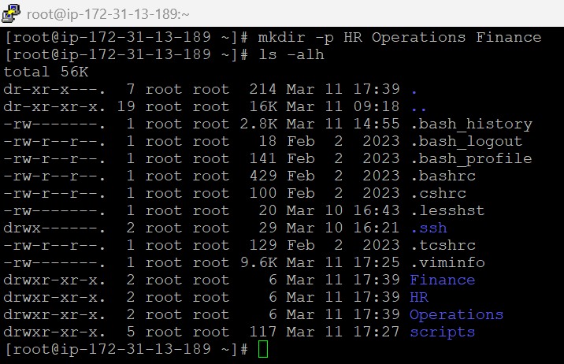



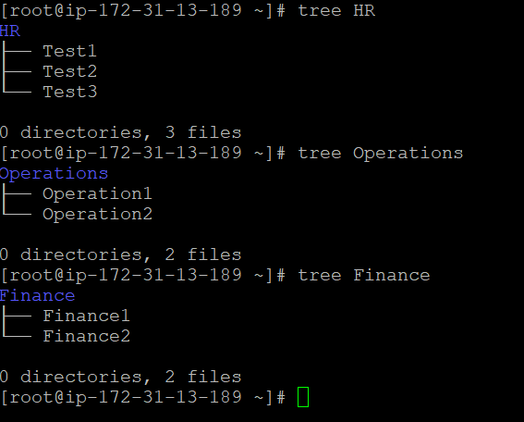

2. Copy the test1 file from HR directories to Finance directories.

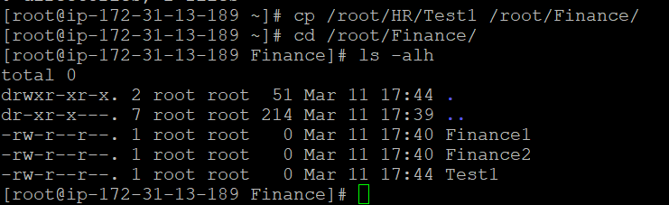

3. Create a directory called Account under the Finance directory.

Account1.csv

Account2.csv



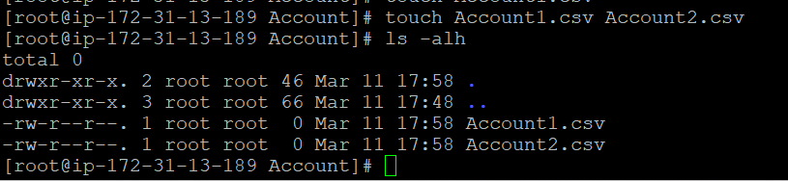

4. Copy all the entire structure of Finance directory to Operation directory.

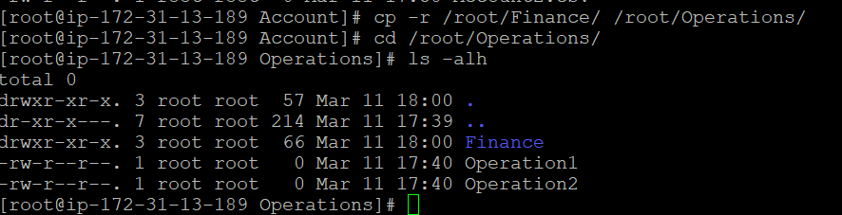

5. Rename Account2.csv to Employee.csv.

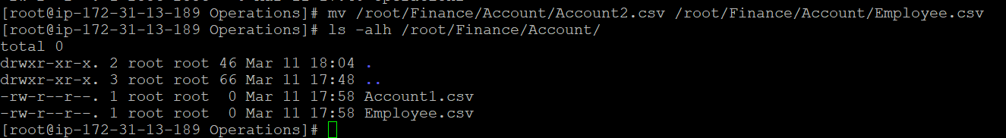

6. Move the file Test1 to Operations.

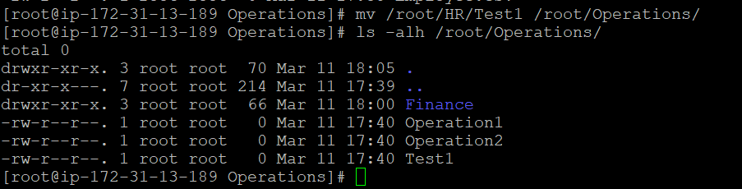

7. Move all the files from HR directory Operation directory.

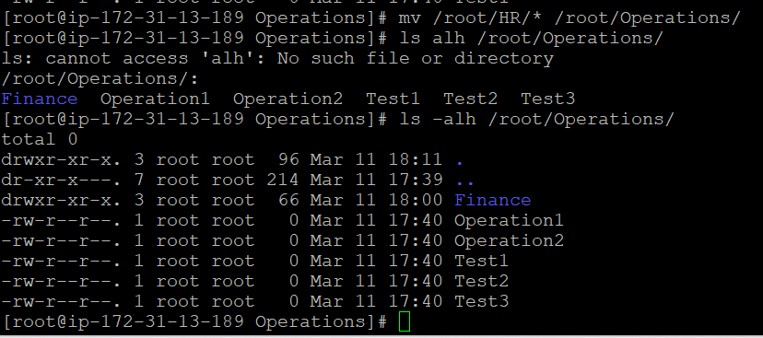

8. Delete all the files which is present in HR directory.

The files from HR directory were already moved to Operation directory in the previous step.

Command : **rm /root/HR/\***

9. Remove the entire Finance directory from Operation directory.

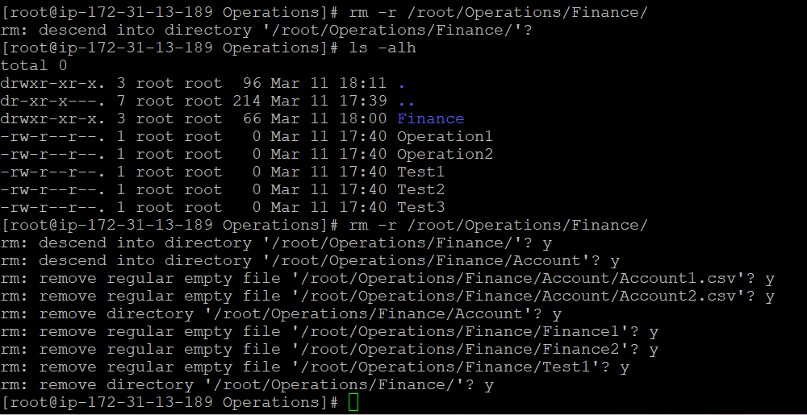

10. Display the content of Account2.csv.

**Account2.csv was renamed as Employee.csv**

11. List all the files which is present in Finance directory except directory.

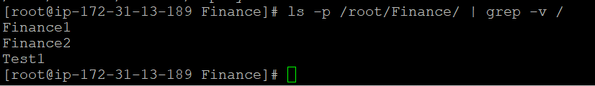

12. Display all the users connected to Ubuntu.

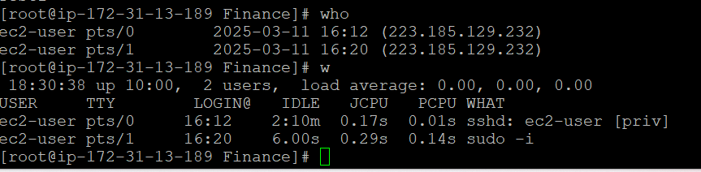

13. Search for all the files starting with T from the home directory.

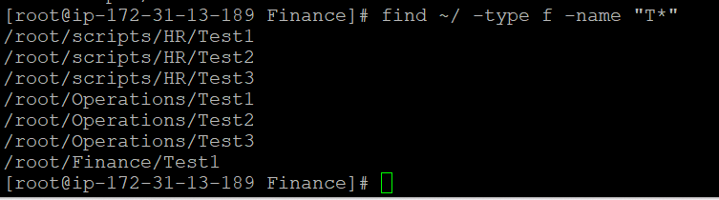

14. Create hidden file called “Test” under Finance directory.

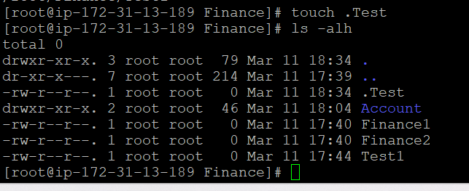

15. Display all the process running in the Ubuntu system.

